**KABARAK UNIVERSITY**

**PROJECT TITLE: INNOVATIVE PUBLIC TRANSPORT NOTIFICATION SYSTEM**

SCHOOL OF BUSINESS AND ECONOMICS

BBIT 414: PROJECT 1

**PRESENTED BY:** DERICK KIPLIMO

**REGISTRATION NUMBER:**

BBIT/MG/2589/09/20

**PROJECT PROPOSAL SUBMITTED TO SCHOOL OF BUSINESS (DEPARTMENT OF COMMERCE) IN PARTIAL FULFILMENT FOR THE AWARD OF THE DEGREE IN BACHELOR OF BUSINESS INFORMATION TECHNOLOGY.**

**MAY - AUGUST 2024**

# DECLARATION AND APPROVAL

A project proposal is submitted to the Department of Commerce in the School of Business and Economics in partial fulfillment of the requirements for the award of the Bachelor’s degree in Business Information Technology at Kabarak University. This project is my original work and had not been presented anywhere as a pre-requisite for the award of a Bachelor’s degree in any other university.

**Name:**

DERICK KIPLIMO BBIT/MG/2589/09/20

**Signature………………………… Date………………………**

**APPROVAL BY THE SUPERVISOR**

This project was submitted for examination with my approval as university

Supervisor: SIMON RUORO

Signature ……………………………… Date ……………………………………

# 

# DEDICATION

I dedicate this project to the Almighty God for His divine guidance and protection throughout the development of the Innovative Public Transport Notification System. Without His mercy and grace, this project would not have been possible. I extend my sincere gratitude to all the individuals and stakeholders whose collective efforts and unwavering support have brought this system from conception to realization. Special appreciation goes to the stakeholders including passengers, transport operators, and system administrators who generously shared their insights, experiences, and time. Their contributions have been instrumental in shaping a solution that prioritizes passenger satisfaction, operational efficiency, and sustainability in public transportation systems. Their commitment and collaboration have been invaluable in creating a seamless and enhanced travel experience for all commuters.

# ACKNOWLEDGMENT

# In acknowledging the realization of the Innovative Public Transport Notification System, heartfelt appreciation was extended to the diverse individuals and organizations whose collaborative efforts were pivotal in shaping this initiative. Special thanks were owed to the passengers, transport operators, and system administrators for their active engagement and valuable feedback, which were instrumental in the system's development. Particular recognition was reserved for those who participated in surveys and interviews, generously sharing their experiences and insights. Their input significantly contributed to the user-centric design of the system, enhancing its effectiveness and usability. The guidance and expertise provided by technical professionals, consultants, and industry experts were invaluable throughout the project, ensuring the system's robustness and functionality. Gratitude was extended to my university supervisor, Mr. Simon Ruoro, whose expertise, feedback, and guidance were indispensable in shaping the system's design and functionality. His unwavering dedication and support were deeply appreciated, and I was grateful for the opportunity to have collaborated with him.

# ABSTRACT

In the dynamic landscape of public transportation, the need for efficiency, transparency, and accountability had never been more crucial. Traditional transport systems often suffered from delays, lack of transparency, and operational inefficiencies. Public transport systems were plagued by these issues, leading to unpredictable schedules, opaque processes, and increased susceptibility to errors. The lack of real-time updates and manual handling of information contributed to a lack of trust in public transport services across the nation. These challenges highlighted the urgent need for a comprehensive and technology-driven solution.

The existing challenges in public transportation were multifaceted; inadequate passenger information, unpredictable schedules, and complicated fare management processes contributed to inefficiencies in the sector. Additionally, the absence of a centralized tracking mechanism made it difficult to monitor bus locations and schedules in real-time, hindering timely decision-making for both passengers and transport operators. This necessitated a system that could enhance the user experience and streamline operations. I therefore proposed the "Innovative Public Transport Notification System," which aimed to revolutionize the public transportation landscape by introducing a seamless, transparent, and efficient platform for passengers and transport operators. By leveraging technology, this system sought to eliminate manual bottlenecks, enhance communication, and instill confidence in passengers through real-time tracking and reporting. The proposed system provided passengers with comprehensive, real-time information about bus stops, available routes, departure times, booking options, fare amounts, and receipts.

The proposed system was built on a robust and scalable technological framework, utilizing the latest advancements in GPS tracking, mobile applications, and digital payment systems. A user-friendly interface facilitated easy navigation for passengers, while transport operators benefited from streamlined operations and enhanced efficiency. Features such as automated route updates, real-time status notifications, and data-driven insights were integrated to ensure a comprehensive and efficient public transportation ecosystem. This solution promised to significantly improve the passenger experience, increase operational efficiency, and encourage greater use of public transportation by making it a more reliable and convenient option to commuters.

Contents

DECLARATION AND APPROVAL i

**APPROVAL BY THE SUPERVISOR** i

DEDICATION ii

ACKNOWLEDGMENT iii

ABSTRACT iv

CHAPTER ONE 1

**INRODUCTION** 1

**1.1 Background of the study** 1

**1.3 Objectives** 3

**1.4 Research Questions** 4

**1.5 Proposed System** 4

**1.6 System Modules** 4

**1.7 Justification of the study** 5

**1.8 Feasibility Study** 5

**1.9 Significance of the study** 6

**1.10 scope and limitation of the study** 7

CHAPTER TWO 8

**2.1 Literature Review** 8

**2.2 Overview of the Main Topic** 9

**2.3 Methods of identifying feature selection techniques** 9

**2.3.1 Literature Review** 9

**2.3.2 Consultation with Experts** 10

**2.3.3 Comparative Analysis** 10

**2.3.4 Prototype Development** 10

**2.3.5 Data Analysis and Experimentation** 10

**2.4 Evaluation of the correlation between optimal features** 10

**2.5 User Security Awareness Level for the Proposed System** 11

**2.6 Prototype Design** 12

**2.7 Design framework** 13

**2.7.1 System Architecture** 13

**2.7.2 User Interface (UI) Design** 13

**2.7.3 Data Management and Analytics** 13

**2.7.4 Notification System** 14

**2.7.5 System Security** 14

**2.7.6 Testing and Quality Assurance** 14

CHAPTER THREE 16

3.1 RESEARCH DESIGN METHODS 16

**3.2 Location of study** 17

**3.3 Population of Study** 17

**3.4 SAMPLING PROCEDURE AND SAMPLE SIZE** 17

**3.5 DATA COLLECTION PROCEDURE** 18

**3.6 SYSTEM DEVELOPMENT METHODOLOGY** 19

**3.7 SYSTEM ANALYSIS AND DESIGN** 19

REFERENCES 25

**APPENDIX 1** 26

**APPENDIX 2** 26

# LIST OF FIGURES

Figure 1: Concept Diagram 15

Figure 2: Context Diagram 21

Figure 3: Use Case Diagram 22

Figure 4: Data Flow Diagram 23

Figure 5: Database Diagram 24

# 

# CHAPTER ONE

## **INRODUCTION**

### **1.1 Background of the study**

Public transportation systems globally grappled with numerous challenges impacting their efficiency, reliability, and user satisfaction. Rapid urbanization, increasing population densities, and evolving commuter needs exacerbated these issues, necessitating innovative solutions to improve service delivery. The proposed Innovative Public Transport Notification System aimed to address these problems by leveraging modern technology to provide real-time information and enhance the overall commuting experience.

One of the primary issues in public transportation was the lack of real-time information for passengers. Traditional systems often relied on static schedules and printed timetables that failed to account for unexpected delays, route changes, or varying traffic conditions. This absence of dynamic information led to passenger frustration, missed connections, and a decrease in the reliability of public transport services. Pyshkin, Baratynskiy, Chisler, & Skripal (2016, September) underscored that real-time information significantly enhanced passenger satisfaction and reduced perceived waiting times. Additionally, inefficiencies in route management and communication plagued public transport operators. Traffic congestion, roadworks, and unforeseen circumstances complicated effective route management. Without a robust system to dynamically adjust routes and inform passengers, these issues resulted in delays and inefficiencies. Efficient route management was essential for maintaining the punctuality and reliability of public transportation systems.

Moreover, traditional fare collection and ticketing methods were cumbersome and prone to errors. Passengers often struggled to understand fare structures, purchase tickets, and obtain receipts. The lack of integrated booking options and electronic payment systems further exacerbated these problems, making public transportation less convenient compared to other modes of transport. By integrating electronic payment systems, fare collection was streamlined, enhancing the overall user experience.

Digital technologies presented a unique opportunity to address these challenges. The system aimed to leverage these technologies to provide real-time updates on bus stops, available routes, departure times, booking options, fare amounts, and digital receipts. By integrating cloud computing, data analytics, and mobile applications, the system sought to offer a seamless and user-friendly experience for passengers. Cloud computing ensured scalable and reliable service delivery, allowing the system to handle high volumes of user data and provide real-time updates without downtime. APIs connected the system with various data sources, such as GPS and traffic updates, to provide accurate information. Predictive analytics and machine learning algorithms enhanced the system's ability to forecast delays and adjust routes dynamically, improving overall efficiency and reliability.

The user interface design focused on accessibility and ease of use. A responsive design allowed passengers to access the system on various devices, including smartphones, tablets, and desktops. Personalized user profiles enabled passengers to save their preferences and receive customized notifications, while multilingual support catered to a diverse user base, including non-native speakers and tourists. Ferreira, Rodríguez, & Juristo (2020) emphasized the importance of usability in enhancing user satisfaction and engagement.

Data security and privacy were critical components of the proposed system. The increasing prevalence of cyber threats necessitated robust security measures to protect user data and ensure compliance with privacy regulations. The system implemented encryption, secure data storage, and access control mechanisms to safeguard sensitive information. Regular security audits and threat detection systems further enhanced the system's resilience against potential attacks.

Comprehensive testing validated the system's functionality, performance, and security. Various testing procedures, including unit testing, integration testing, system testing, and user acceptance testing, identified and addressed potential issues. This rigorous approach to quality assurance ensured that the system met user requirements and operated reliably under different conditions.

The proposed Innovative Public Transport Notification System aimed to revolutionize public transportation by addressing key challenges related to real-time information, route management, fare collection, and user communication. By leveraging modern technologies and emphasizing user-centric design, the system sought to enhance the overall commuting experience and improve the efficiency and reliability of public transport services. The successful implementation of this system not only benefited passengers but also contributed to the sustainable development of urban transportation infrastructure.

**1.2 Problem statement**

### Current public transportation systems faced inefficiencies, unreliable schedules, poor passenger information, and cumbersome fare management, leading to dissatisfaction and decreased usage. These issues led to unreliable and generalized information, causing delays and dissatisfaction among commuters. Additionally, the absence of localized features that catered to the specific needs of regional transit networks further exacerbated the problem, leaving users without timely and relevant updates. There was a clear need for a more comprehensive, reliable, and user-centric innovative public transport notification system that addressed these shortcomings to enhance the overall commuter experience.

### **1.3 Objectives**

#### **1.3.1 General Objective**

#### The "Innovative Public Transport Notification System" was developed to enhance the efficiency, transparency, and user experience of public transportation systems by leveraging modern technology. This system aimed to provide passengers with real-time information on bus stops, available routes, departure times, booking options, fare amounts, and receipts through an integrated, user-friendly platform. By automating and centralizing these processes, the project sought to reduce operational inefficiencies, minimize errors, and improve overall passenger satisfaction and trust in public transportation services.

#### **1.3.2 Specific Objectives**

### An extensive investigation was conducted to identify and analyze the current challenges and inefficiencies in existing public transportation systems. This investigation focused on areas such as unpredictable schedules, inadequate passenger information, and complex fare management processes within the targeted transport organizations.

### A detailed system design was developed based on the findings from the investigation phase. This involved creating various models, including use case diagrams and activity diagrams, to illustrate the proposed functionalities and interactions within the Innovative Public Transport Notification System.

### The development and implementation of the Innovative Public Transport Notification System were executed according to the designed specifications. This phase encompassed coding, configuration, and integration of system components to ensure seamless operation and user accessibility.

### Thorough testing was conducted to verify system functionality, performance, and security. This included unit testing, integration testing, system testing, and user acceptance testing to ensure system requirements were met.

### **1.4 Research Questions**

### What were the key challenges and inefficiencies previously faced in conventional public transportation systems?

### How did the proposed system design adequately tackle the identified challenges in traditional public transportation systems?

### How did the development and implementation of the Innovative Public Transport Notification System ensure scalability, maintainability, and adherence to security standards?

### What was the efficacy of the testing methods utilized to verify the functionality, performance, and security of the deployed system?

### **1.5 Proposed System**

### The proposed system was an Innovative Public Transport Notification System designed to address inefficiencies in current transportation services by offering real-time updates, reliable schedules, comprehensive passenger information, and streamlined fare management, aiming to enhance user satisfaction and increase usage.

### **1.6 System Modules**

i. Real-time Updates Module**:** Provides live information on bus schedules, routes, and availability to passengers.

ii. Scheduling and Management Module: Manages and optimizes bus schedules, ensuring reliability and efficiency.

iii. Passenger Information Module: Offers detailed information on bus stops, routes, and travel options to enhance user experience.

iv. Fare Management Module: Calculates and manages fare payments digitally, providing transparency and ease of transaction for commuters.

### **1.7 Justification of the study**

### Improved Passenger Satisfaction: The Innovative Public Transport Notification System is aiming to boost passenger satisfaction by addressing existing challenges in traditional public transportation systems. Real-time updates on bus stops, routes, schedules, and fares are minimizing uncertainty and waiting times, ultimately leading to a more positive passenger experience.

### Streamlined Operations: Implementing the notification system is streamlining operations for transport providers, resulting in more efficient management of routes, schedules, and fare transactions. Through automation and centralization of processes, the system is reducing errors and administrative workload, thereby enhancing overall operational efficiency.

### Cost-Efficiency: The Innovative Public Transport Notification System is having the potential to generate cost savings for passengers and transport operators alike. By optimizing route planning and resource allocation, the system is reducing fuel consumption and operational expenses for transport providers. Additionally, by promoting increased public transport usage, it is mitigating traffic congestion and environmental impact, leading to long-term cost savings.

### Informed Decision Making: The implementation of the notification system is providing valuable insights into passenger behavior, route performance, and system usage patterns. By analyzing this data, transport operators are making informed decisions to optimize services, improve route planning, and enhance system reliability, ensuring continuous adaptation to passenger needs and preferences.

### **1.8 Feasibility Study** The feasibility study for the Innovative Public Transport Notification System examined its technical, economic, and operational viability. Technical feasibility involved assessing whether the necessary technology for real-time updates, scheduling, passenger information, and fare management was both available and feasible to implement effectively. Economic feasibility evaluated the cost-effectiveness of developing and maintaining the system in comparison to potential benefits, such as reduced operational costs and increased passenger utilization. Operational feasibility focused on how well the system integrated with existing transportation infrastructure, its ease of adoption by users and stakeholders, and potential impacts on operations. Additionally, the study considered legal compliance and environmental impacts to ensure the system met regulatory requirements and minimized environmental consequences during implementation and operation. These analyses collectively determined the practicality and potential success of implementing the Innovative Public Transport Notification System to improve public transportation services.

### **1.9 Significance of the study**

### Enhanced Passenger Experience: By addressing existing challenges in traditional public transportation systems, the study greatly enhanced the overall passenger experience. Real-time updates on bus stops, routes, schedules, and fares resulted in reduced waiting times, increased convenience, and higher satisfaction levels among passengers.

### Efficiency and Sustainability: Through streamlined operations and optimized resource allocation, the implementation of the Innovative Public Transport Notification System contributed to improved efficiency and sustainability in public transportation. This included reducing fuel consumption, minimizing operational costs, and mitigating environmental impact through decreased traffic congestion and emissions.

### Enhanced Accessibility: The study enhanced accessibility to public transportation for all community members, including those with mobility challenges or limited access to transportation options. Improved information dissemination and real-time updates made public transportation more accessible and user-friendly for everyone.

### Data-Driven Decision Making: Through data analysis, the study provided valuable insights into passenger behavior, route performance, and system usage patterns. This data-driven approach empowered transport operators to make informed decisions, optimize services, and enhance overall system reliability, ensuring that public transportation met the evolving needs of passengers effectively.

### Economic Benefits: By increasing public transportation usage and efficiency, the Innovative Public Transport Notification System generated economic benefits for both passengers and transport operators. This included cost savings for passengers through reduced travel times and optimized fares, as well as increased revenue and operational efficiency for transport providers.

### **1.10 scope and limitation of the study**

Development and Implementation: The study focused on the development and implementation of the Innovative Public Transport Notification System, including designing the system architecture, coding, configuration, and integration of system components.

Data Analysis: The study involved data analysis to gain insights into passenger behavior, route performance, and system usage patterns, enabling data-driven decision-making to optimize services and improve overall system reliability.

Functionality and User Experience: The study assessed the functionality and user experience of the notification system, including real-time updates on bus stops, routes, schedules, fares, and booking options, to enhance passenger satisfaction and operational efficiency.

Operational Considerations: The study faced operational constraints related to the integration of the notification system with existing public transportation infrastructure, as well as regulatory compliance and stakeholder cooperation, which impacted project implementation and sustainability.

**Top of Form**

**Bottom of Form**

# 

# CHAPTER TWO

## **2.1 Literature Review**

## The advent of advanced information technology revolutionized public transport systems globally, significantly enhancing passenger experiences through real-time updates and notifications. Various notification systems were developed to keep passengers informed, reduce waiting times, and improve overall satisfaction. However, despite the progress, these systems often exhibited limitations in personalization, data accuracy, integration of multiple transport modes, and accessibility in areas with poor connectivity. This literature review examined existing public transport notification systems, identified their strengths and weaknesses, and highlighted the research gaps that needed to be addressed to develop a more comprehensive and user-centric solution.

## Globally, NextBus and Moovit were prominent public transport notification systems that enhanced commuter experiences. NextBus, based in the USA, leveraged GPS technology to provide real-time arrival predictions for buses and trains, allowing passengers to know exactly when their transit would arrive. Moovit, a global mobility-as-a-service app, offered real-time public transit information and live navigation by collecting data from transit agencies and users, helping commuters plan their journeys and receive real-time updates on delays and disruptions.

## In Kenya, Ma3Route and Ndovu App served as key platforms for navigating public transport. Ma3Route crowdsourced real-time traffic updates and public transport information, helping commuters in Nairobi and other cities plan their journeys more effectively. The Ndovu App focused on Nairobi’s matatu system, providing GPS-tracked updates on matatu locations, schedules, and route changes, enabling passengers to navigate the city’s informal transport system with greater ease.

## Despite the advancements in public transport notification systems, significant gaps remained that needed to be addressed. Current systems often lacked personalized notifications tailored to individual user preferences, leading to a one-size-fits-all approach that failed to meet specific needs. Additionally, many platforms struggled with data accuracy and consistency, particularly when integrating multiple transport modes, resulting in unreliable information for users. Moreover, many existing systems lacked localized features and specific transit functionalities, which were crucial for addressing the unique challenges of regional public transport networks. Addressing these gaps was essential for creating a more comprehensive, reliable, and user-friendly innovative public transport notification system.

## My innovative public transport notification system aimed to solve these gaps by offering personalized notifications that catered to individual user preferences, ensuring that passengers received relevant updates tailored to their specific needs. The system employed advanced data validation techniques to enhance accuracy and consistency, particularly in integrating multiple transport modes, thereby providing reliable information to users. Additionally, the system featured localized functionalities, such as real-time updates specific to regional transit networks, making it more adaptable and responsive to the unique challenges of different public transport environments.

Bottom of Form

## **2.2 Overview of the Main Topic**

## The Innovative Public Transport Notification System sought to tackle the common issues in traditional public transportation systems through the use of advanced technology. Its primary objective was to improve both the passenger experience and operational efficiency by offering real-time information on bus stops, routes, departure schedules, booking options, fare details, and receipts. By consolidating these features into a single, intuitive platform, the system aimed to reduce uncertainties, shorten waiting times, and enhance the overall dependability and accessibility of public transport. This forward-thinking solution was designed not only to streamline operations for transport providers but also to encourage greater use of public transportation, thereby supporting sustainable urban mobility.

## **2.3 Methods of identifying feature selection techniques**

### **2.3.1 Literature Review**

Conducted a thorough literature review to identify existing feature selection techniques used in similar systems or domains. This involved studying academic papers, industry reports, and case studies that discussed methodologies and algorithms for selecting relevant features in transportation systems.

### **2.3.2 Consultation with Experts**

### Engaged with domain experts, such as data scientists, transportation engineers, and technology consultants, to gather insights on effective feature selection methods. Experts provided valuable guidance based on their experience and knowledge of best practices in the field.

### **2.3.3 Comparative Analysis**

### Benchmarking was conducted against existing public transport notification systems or similar technological solutions to understand which feature selection techniques had been successful in improving system performance, user experience, and operational efficiency.

### **2.3.4 Prototype Development**

### Developed a prototype or proof-of-concept of the notification system to experiment with different feature selection techniques. This hands-on approach allowed for empirical evaluation of techniques under realistic conditions, providing practical insights into their effectiveness.

### **2.3.5 Data Analysis and Experimentation**

Analyzing historical data and conducting experiments to evaluate the impact of different feature selection techniques on system metrics such as accuracy, responsiveness, and user satisfaction. This empirical approach helps in identifying techniques that yield the best results for the specific requirements of the public transport notification system.

## **2.4 Evaluation of the correlation between optimal features**

## Evaluated the correlation between the optimal features of the Innovative Public Transport Notification System by analyzing how these features interacted and complemented each other to enhance overall system performance and user experience.

## The real-time updates module worked in tandem with the scheduling management module to ensure passengers received accurate and timely information. Reliable schedules were maintained through constant updates, reducing passenger wait times and improving service reliability. The correlation between these features ensured that any changes in schedules were immediately communicated to users, enhancing their travel planning and reducing uncertainty.

## The passenger information module provided comprehensive details on bus stops, routes, and travel options, which were essential for informed travel decisions. When integrated with the fare management module, passengers not only received travel information but also had a seamless experience in calculating and managing their fares. This synergy enhanced user satisfaction by providing a complete travel solution, from route planning to fare transactions, within a single system.

## The interaction between real-time updates, scheduling management, and passenger information modules collectively boosted operational efficiency. Accurate schedules and timely information streamlined bus operations and reduced congestion. This, in turn, improved the overall user experience as passengers benefited from reliable services and easy access to information. The fare management module added to this efficiency by simplifying transactions, reducing the need for physical currency exchanges, and speeding up boarding processes.

## Ensuring legal compliance and considering environmental impacts were essential for the sustainable operation of the system. Features such as real-time updates and digital fare management contributed to reduced paper usage and lower emissions by optimizing bus schedules and reducing unnecessary trips. This correlation not only aligned with regulatory requirements but also promoted environmentally friendly practices.

## **2.5 User Security Awareness Level for the Proposed System**

## Enhancing user security awareness was essential for the effective implementation and operation of the Innovative Public Transport Notification System. To start, assessing current awareness levels among users, including passengers and transport operators, through surveys and interviews was crucial. This assessment helped identify common knowledge gaps and misconceptions about cyber security and data privacy.

## Educational initiatives played a vital role in raising awareness. Targeted campaigns were launched to highlight the importance of cyber security, utilizing various channels like social media, email newsletters, and in-app notifications to spread security information effectively. Additionally, developing thorough training programs for transport operators and administrative staff was necessary. These programs covered best security practices, including recognizing phishing attempts, protecting personal data, and effectively using the system’s security features.

## Clear and simple user guidelines were also essential. These guidelines provided instructions on essential security practices, such as creating strong passwords, regularly updating the app, and reporting suspicious activities. Regular security updates were another key aspect, keeping users informed about the latest security measures and encouraging them to update the app regularly to benefit from improved security features.

## Establishing feedback mechanisms, like surveys and user forums, allowed for gathering user opinions on security features and educational content. This feedback was invaluable for continuously improving security awareness programs and addressing new concerns. Lastly, implementing tools to monitor and report potential security breaches or risky user behavior was important. Clear instructions were provided for users to report security issues, ensuring quick responses to such reports.

## By focusing on these areas, the proposed system significantly improved user security awareness, ensuring better protection of user data and maintaining system integrity.

## **2.6 Prototype Design**

## The prototype design outlined the key user interfaces and interactions for the proposed Innovative Public Transport Notification System. Each module was designed to provide specific functionalities that contributed to an efficient and user-friendly experience. The Home Screen provided easy navigation to all primary modules. The Login/Sign Up screen ensured secure access to the system. The Real-time Updates module offered timely information about bus arrivals and delays. The Scheduling Management module allowed users to plan their travel efficiently. The Passenger Information module provided detailed route and stop information. The Fare Management module facilitated fare calculations and transactions. Lastly, the Settings module allowed users to customize their preferences and manage their profiles.

## By focusing on these core components, the prototype design aimed to address the primary challenges of public transportation, enhancing both operational efficiency and passenger satisfaction.

## **2.7 Design framework**

The design framework for the Innovative Public Transport Notification System was crafted to deliver a seamless, user-friendly, and secure experience. This framework covered several essential components, each targeting specific objectives and needs.

### **2.7.1 System Architecture**

### Modular Design: The system featured a modular architecture to ensure scalability and adaptability. Each module handled distinct functions, such as real-time notifications, route management, fare calculations, and user interactions.

### APIs and Integrations: APIs were used to integrate with external data sources (e.g., GPS data, traffic updates) and other transport modes (e.g., trains, trams) for a comprehensive travel solution.

### **2.7.2 User Interface (UI) Design**

### Responsive Design: A responsive and intuitive user interface was designed, accessible across various devices (smartphones, tablets, desktops) to ensure a consistent user experience.

### User Profiles: Personalized user profiles were implemented where passengers could save preferences, favorite routes, and receive customized notifications.

### Multilingual Support: Multilingual capabilities were offered to cater to a diverse user base, improving accessibility for non-native speakers and tourists.

### **2.7.3 Data Management and Analytics**

### Real-Time Data Processing: Real-time data processing was implemented to provide up-to-date information on bus arrivals, departures, and route changes, using stream processing frameworks for efficient continuous data flow management.

### Analytics: AI and machine learning algorithms were used to predict bus arrival times, potential delays, and traffic patterns, enhancing notification accuracy and travel planning.

### Data Security and Privacy: Strong data security measures were ensured, including encryption, secure data storage, and compliance with privacy regulations to protect user data.

### **2.7.4 Notification System**

### Real-Time Alerts: Real-time notifications were provided to users about bus stops, available routes, departure times, and fare information via mobile apps, SMS, and email.

### Booking and Payment Integration: Booking options and fare payments were facilitated directly through the system, integrating with popular payment gateways for secure transactions.

### Receipts and History: Digital receipts were offered, and transaction history was maintained for user reference and transparency.

### **2.7.5 System Security**

### Access Control: Role-based access control was implemented to ensure only authorized users (e.g., transport operators, administrators) could access specific system functionalities.

### User Training and Awareness: Regular training sessions and educational resources on best security practices were provided, ensuring users knew how to protect their personal information.

### **2.7.6 Testing and Quality Assurance**

Comprehensive Testing: Thorough testing procedures were conducted, including unit testing, integration testing, system testing, and user acceptance testing, to validate the system’s functionality, performance, and security.

Continuous Improvement: A feedback loop was implemented to collect user feedback regularly and use it to make iterative improvements, ensuring the system evolved to meet user needs and expectations.

By incorporating these components, the design framework for the Innovative Public Transport Notification System ensured a robust, efficient, and user-centric solution that enhanced the overall public transportation experience.

**CONCEPT MAP**

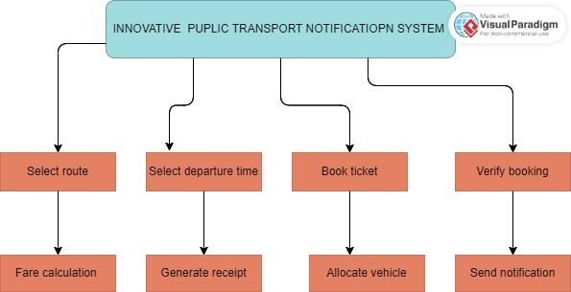

Figure 1: Concept Diagram

# 

# CHAPTER THREE

# 3.1 RESEARCH DESIGN METHODS

#### Research design methods provided structured approaches to investigating and addressing research questions. These methods guided the collection, analysis, and interpretation of data, ensuring the study was systematic and reliable. Descriptive research designs focused on observing and documenting current phenomena, while exploratory designs investigated potential solutions and innovations. Mixed-methods combined qualitative and quantitative approaches for comprehensive analysis, and experimental designs tested new interventions in controlled settings. Each method contributed uniquely to understanding, developing, and evaluating the subject of study, ensuring robust and actionable insights.

#### **3.1.1 Descriptive Research Design**

#### This method involved observing and documenting the current state of the public transport system in Eldoret. Through surveys and interviews with commuters, drivers, and transport authorities, this design gathered detailed and accurate information about existing infrastructure, notification systems, and user experiences. This foundational data highlighted key issues and user needs, providing a comprehensive understanding of the current scenario and guiding areas for improvement and innovation within the notification system.

#### **3.1.2 Mixed-Methods Research Design**

#### Combining both qualitative and quantitative approaches, this method provided a well-rounded analysis of the proposed notification system's effectiveness. Quantitative surveys and statistical analysis measured user satisfaction, system usability, and the impact on commuter experience. Qualitative methods like focus groups and in-depth interviews offered deeper insights into user perceptions, preferences, and suggestions for improvement. This approach ensured a comprehensive evaluation of the system's performance and stakeholder acceptance.

#### **3.1.3 Experimental Research Design**

### This method tested the feasibility and effectiveness of the proposed notification system by developing a pilot version and deploying it in a selected area within Eldoret. Data on system usage, reliability, and commuter feedback were collected during the experimental period. Comparing the new system's performance against existing methods assessed its impact on reducing waiting times, improving commuter satisfaction, and enhancing overall transport efficiency.

### **3.2 Location of study**

### The location chosen for this study was Eldoret, a bustling town in Kenya's Rift Valley region. Eldoret served as a vital economic hub and a key transit point, making it an ideal setting for examining public transport systems. With its rapidly growing population and diverse commuter base, Eldoret faced unique challenges and opportunities in public transportation. The town's dynamic environment and expanding infrastructure provided a rich context for exploring innovative solutions to improve transport notification systems. By focusing on Eldoret, the study aimed to address the specific needs of its residents and contribute to enhancing the efficiency and user experience of the local public transport network.

### **3.3 Population of Study**

### The population of this study encompassed a diverse group of stakeholders within Eldoret's public transport system. This included daily commuters, public transport operators, and transport authorities. The commuter group consisted of individuals from various demographic backgrounds, including students, workers, and business people, reflecting the town's diverse and growing population. Public transport operators included drivers, conductors, and fleet managers who managed the daily operations of buses, matatus, and boda-bodas (motorcycle taxis). Transport authorities involved officials responsible for planning, regulating, and overseeing the public transport system. By engaging these varied groups, the study aimed to capture a comprehensive perspective on the current challenges and potential improvements in the public transport notification system.

### **Top of Form**

### **Bottom of Form**

### **3.4 SAMPLING PROCEDURE AND SAMPLE SIZE**

### Sampling Procedure: The study employed a stratified random sampling procedure to ensure representation from all key stakeholder groups in Eldoret's public transport system. The population was divided into strata based on categories such as daily commuters, public transport operators, and transport authorities. Within each stratum, participants were randomly selected to participate in surveys and interviews. This approach ensured that the sample accurately reflected the diversity of perspectives and experiences within the public transport ecosystem.

### Sample Size: The sample size for this study was determined based on the need for statistical reliability and the diversity of the population. A total of 300 participants were selected, with approximately 200 daily commuters, 70 public transport operators, and 30 transport authorities. This sample size was deemed sufficient to provide meaningful insights and allow for robust statistical analysis, ensuring the study's findings were both valid and generalizable to the broader population of Eldoret.

### **3.5 DATA COLLECTION PROCEDURE**

#### **3.5.1 Quantitative Data Collection Procedure**

#### The quantitative data collection involved distributing structured surveys to a broad sample of daily commuters and public transport operators. These surveys were designed to collect numerical data on various aspects such as user satisfaction, frequency of system use, and specific challenges encountered with the current notification system. Surveys were administered both online, using digital platforms, and in-person at key transport hubs to reach a diverse group of respondents. The data collected was systematically recorded and analyzed using statistical methods to identify trends, patterns, and correlations, providing a comprehensive overview of the current system’s performance and user needs.

#### **3.5.2 Qualitative Data Collection Procedure**

### The qualitative data collection focused on gathering in-depth insights through interviews and direct observations. Semi-structured interviews were conducted with a select group of transport authorities, public transport operators, and a smaller sample of commuters to explore their personal experiences, opinions, and suggestions regarding the public transport notification system. These interviews allowed for open-ended responses and detailed discussions, providing a deeper understanding of underlying issues and perspectives. Additionally, direct observations of transport hubs and routes were performed to capture real-time interactions and behaviors. This qualitative data was analyzed thematically to uncover key insights and inform potential improvements to the notification system.

### **3.6 SYSTEM DEVELOPMENT METHODOLOGY**

### The system development methodology for the public transport notification system followed an Agile approach, characterized by iterative and incremental progress. This methodology involved breaking down the development process into manageable sprints, each delivering a functional component of the system. During each sprint, developers worked closely with stakeholders—including transport authorities and commuters—to gather feedback and refine system features. This iterative process ensured continuous improvement and adaptation based on real-world requirements and user feedback. Regular evaluations and adjustments were made to address emerging needs and challenges, ensuring the final system effectively met the goals of enhancing communication and efficiency within Eldoret's public transport network.

### **3.7 SYSTEM ANALYSIS AND DESIGN**

#### **3.7.1 System Analysis**

#### Requirements Gathering: Information was collected from stakeholders, including commuters, transport operators, and authorities, through surveys, interviews, and observations to understand their needs and issues with the current system.

#### Current System Evaluation: The existing public transport notification methods were analyzed to identify inefficiencies, gaps, and areas for improvement.

#### Requirement Specification: A detailed requirements document was developed, outlining the functional and non-functional needs of the new system, based on the analysis of collected data.

#### **3.7.2 System Design**

Architectural Design: The overall system architecture was defined, including the structure of hardware and software components, data flow, and integration points.

User Interface Design: Detailed designs for the system’s user interfaces were created, ensuring they were intuitive and met the needs of all user groups, including commuters and transport operators.

Prototype Development: Prototypes and mock-ups of the system were developed to visualize design concepts, test functionalities, and gather feedback from stakeholders to refine and validate the design.

Design Validation: The design was reviewed and validated with stakeholders to ensure it aligned with the requirements and effectively addressed the identified issues.

**DESIGN DIAGRAMS**

**Context diagram**

A concept diagram was a visual representation used to illustrate the main components, relationships, and flow of a system or idea at a high level. It typically included key entities, their interactions, and the overall structure without delving into technical details.

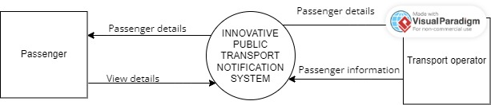

Figure 2: Context Diagram

**Use case diagram**

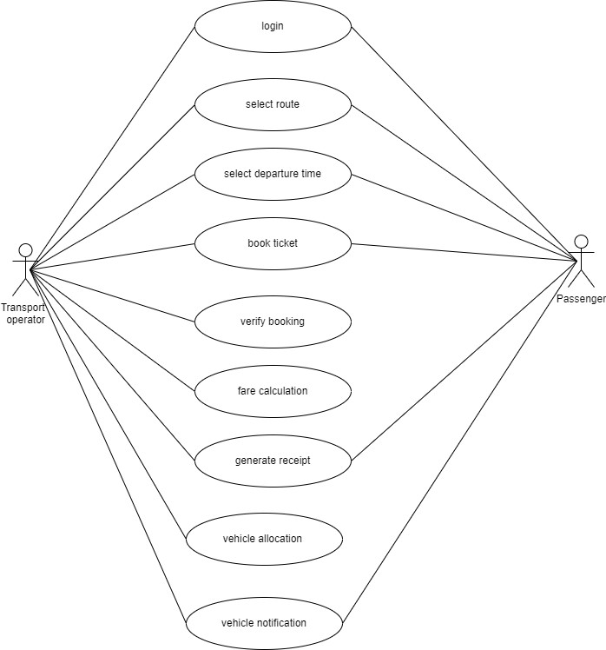

Figure 3: Use Case Diagram

D**ata flow diagram**

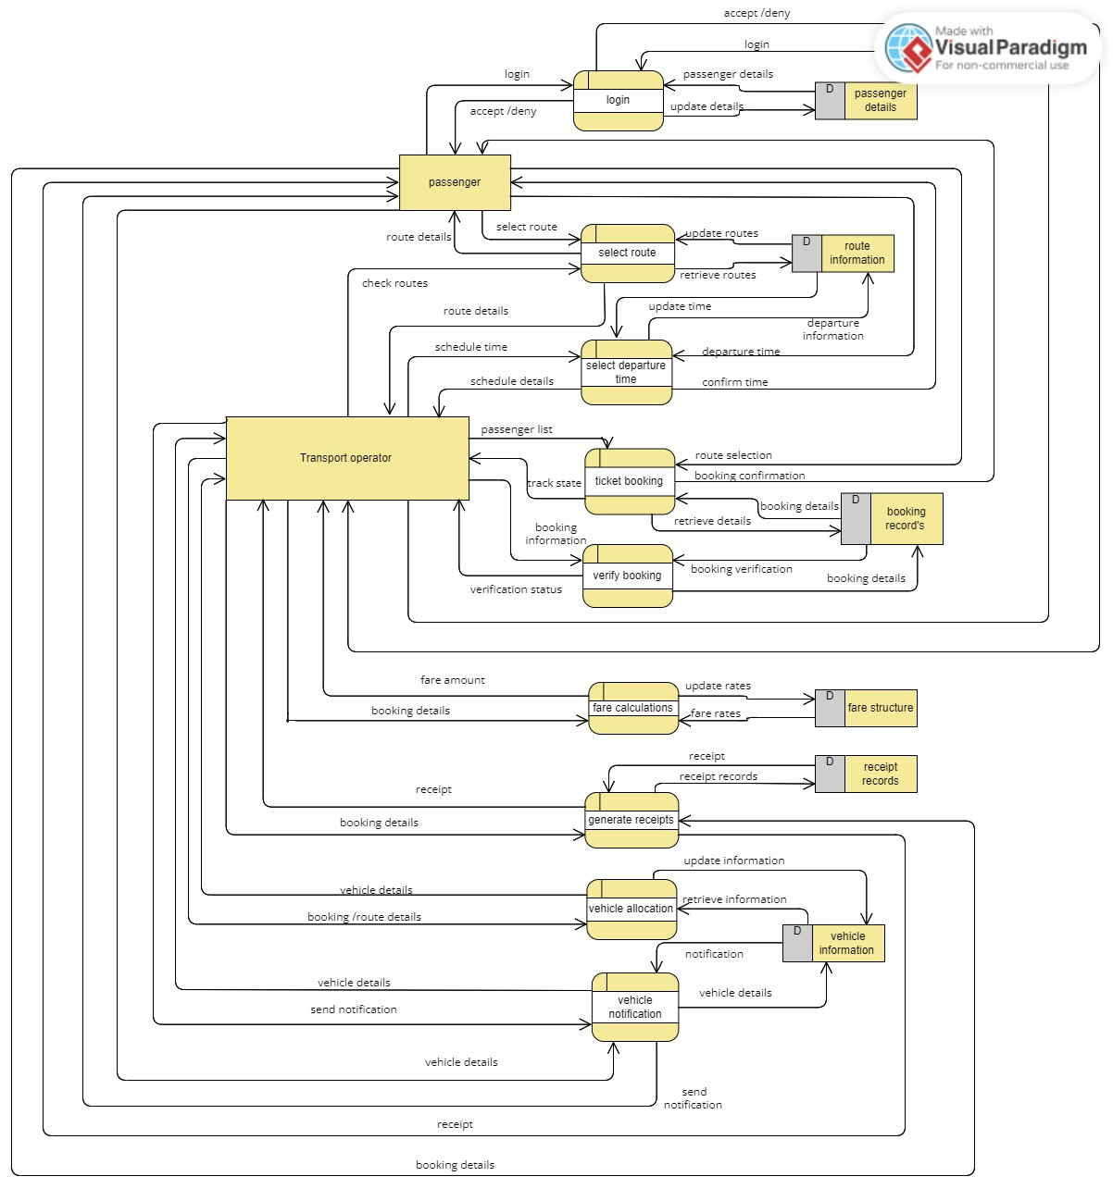

Figure 4: Data Flow Diagram

DATA BASE DESIGN

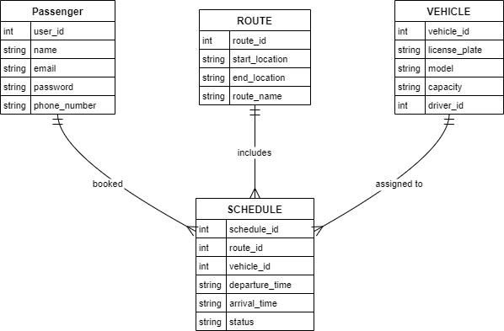

Figure 5: Database Diagram

**CHAPTER FOUR: SYSTEM IMPLEMENTATION AND DEPLOYMENT**

**4.1 Introduction**

This chapter outlines the implementation process of the transport notification app. It explains the system's architecture, front-end and back-end development, database design, testing, and deployment processes. The primary aim of the implementation phase is to translate the system design into a fully functional and user-friendly application.

The app, built with Kotlin and Firebase, allows users to browse car companies, select destinations (e.g., Nakuru to Nairobi), choose departure times, and book seats. The app provides real-time updates on seat availability, ensures seamless booking experiences, and generates tickets for users.

**4.2 System Architecture**

The app architecture follows a **client-server model** using **Firebase Realtime Database** for backend services. The core components include:

1. **Front-End**: Built with Kotlin and Jetpack Compose, providing an interactive and modern UI for users.
2. **Back-End**: Firebase handles authentication, real-time data storage, and retrieval.
3. **Database**: Firebase Realtime Database stores car company information, user bookings, and seat availability.
4. **User Authentication**: Firebase Authentication secures user accounts.

**Diagram**: Include a system architecture diagram illustrating the communication flow between the app, Firebase, and the user.

**4.3 Front-End Development**

The front-end development uses **Jetpack Compose** for creating dynamic, user-friendly UI components. Below is an extract of the Kotlin code for displaying the list of car companies:

kotlin

Copy code

@Composable

fun CarCompanyListScreen(navController: NavController) {

val carCompanies = listOf("Kangaru", "Modern Coast", "Easy Coach") // Sample data

LazyColumn {

items(carCompanies) { company ->

Card(

modifier = Modifier

.padding(8.dp)

.fillMaxWidth()

.clickable {

navController.navigate("destination_screen/$company")

},

elevation = 4.dp

) {

Text(

text = company,

modifier = Modifier.padding(16.dp),

style = MaterialTheme.typography.h6

)

}

}

}

}

This code dynamically displays the car company list and navigates users to a destination selection screen upon clicking a company.

**4.4 User Interface Design**

The user interface prioritizes simplicity and usability. Key UI elements include:

1. **Car Company List**: Displays available transport companies.
2. **Destination Selection**: Users select destinations (e.g., Nakuru to Nairobi).
3. **Seat Booking Screen**: Displays seat availability with booked seats highlighted in green.
4. **Ticket Screen**: Displays user ticket information after successful booking.

**UI Design Tools**

Designs were prototyped using **Figma** before implementation in Jetpack Compose.

**4.5 User Interface Modules**

Below are screenshots and explanations of the core modules:

**4.5.1 Car Company List**

**Screenshot**: Display a screenshot of the car company list screen.  
**Explanation**: This screen allows users to browse available transport providers.

**4.5.2 Seat Booking Screen**

**Screenshot**: Display a screenshot of the seat booking interface with seat availability indicated.

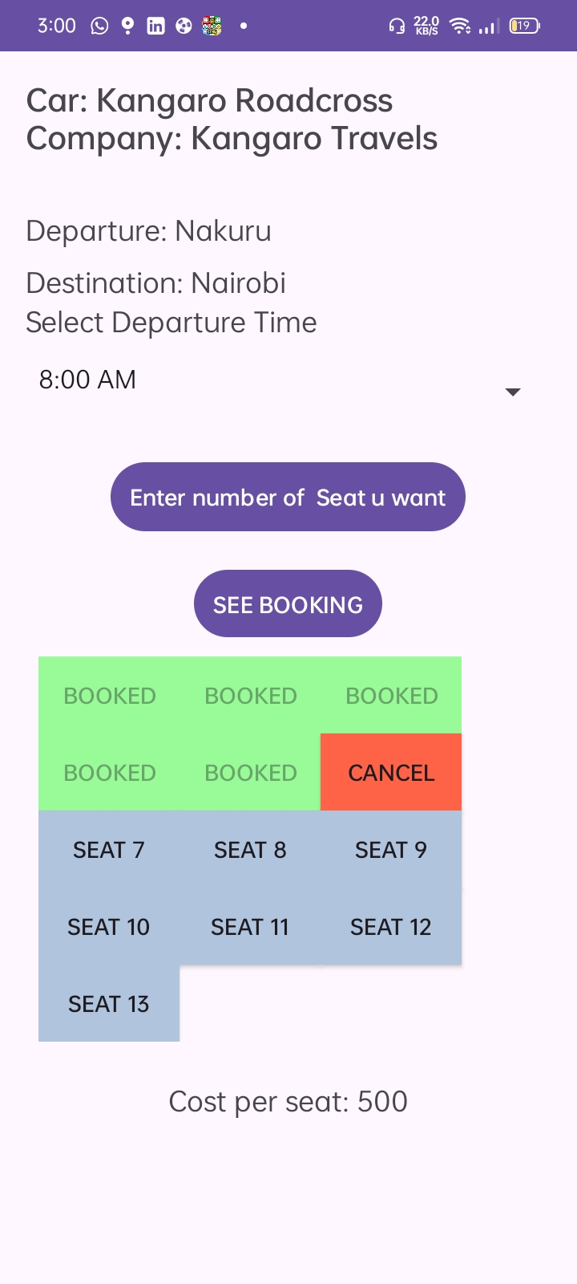

**Explanation**: Users can select available seats (unbooked seats) and see booked seats highlighted in green.

**4.5.3 Ticket Screen**

**Screenshot**: Display a screenshot of a sample ticket.

  
**Explanation**: The ticket includes the departure time, cost, and selected seats.

**4.6 Back-End Development**

**4.6.1 Database Design Models**

The database is structured to store user information, car companies, destinations, and seat bookings. The main collections in Firebase Realtime Database are:

* **Users**: Stores user details (name, email, bookings).
* **CarCompanies**: Stores car company names and destinations.
* **Bookings**: Tracks seat bookings and availability.

**4.6.2 Data Models**

The following data model structures were used:

**Booking Model:**

json

Copy code

{

"bookingId": "abc123",

"userId": "user123",

"carCompany": "Kangaru",

"destination": "Nakuru-Nairobi",

"departureTime": "12:00 PM",

"seats": [1, 2, 3],

"cost": 1500

}

**Firebase Authentication:**

Manages user login and signup securely using Firebase Auth.

**4.6.3 Code Testing**

Unit testing and manual testing were conducted to ensure the app's functionality. Key tests included:

1. **Seat Booking**: Ensuring that once a seat is booked, it is displayed as green and unavailable for other users.
2. **Ticket Generation**: Verifying the correct ticket details are displayed.
3. **Database Integration**: Ensuring data is correctly written to and read from Firebase.

Sample test for seat booking logic:

kotlin

Copy code

@Test

fun testSeatBooking() {

val seatList = MutableLiveData<List<Int>>() // Mock seat data

seatList.value = listOf(1, 2, 3) // Initial booked seats

val newBooking = 4 // Seat being booked

seatList.value = seatList.value?.plus(newBooking)

assertTrue(seatList.value!!.contains(4))

}

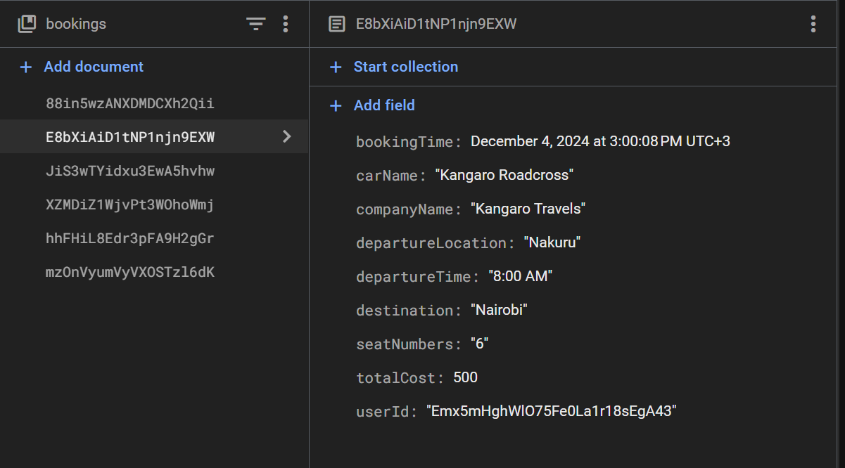

**4.7 Deployment Methods**

The app was deployed using the following methods:

1. **Play Store Deployment**: The app was built into an APK file and uploaded to Google Play Store for distribution.
2. **Debugging with Firebase Emulator**: Firebase Emulator Suite was used for local testing and debugging before deployment.
3. **Continuous Integration**: GitHub Actions automated the build process.

**Steps for Deployment**

1. **Build APK**: Generated release APK using Android Studio.
2. **Configure Play Store Console**: Registered the app and uploaded APK.
3. **Release to Beta Testers**: Conducted a beta test phase before public release.

**4.8 Conclusion and Future Work**

The transport notification app successfully streamlines the seat booking process for users while providing real-time updates on seat availability.

**Future Work**

1. **Add Payment Integration**: Enable users to pay for bookings online.
2. **Notifications**: Implement push notifications for booking reminders and updates.
3. **AI-Powered Recommendations**: Use AI to recommend the best departure times based on user preferences.
4. **Expand Seat Booking**: Allow seat booking for multiple car companies simultaneously.

# REFERENCES

1. Oira, A. S., & Makori, M. (2015). Challenges affecting investment in public transport (Matatu) Industry in Nairobi-Kenya. *Strategic Journal of business & Change management*, *2*(2).
2. Okoth, P. (2017). *Factors influencing customer satisfaction in public transport sector: A case of Matatus in central business district Nairobi-Kenya* (Doctoral dissertation, University of Nairobi).
3. Martens, K. (2016). *Transport justice: Designing fair transportation systems*. Routledge.
4. Hananel, R., & Berechman, J. (2016). Justice and transportation decision-making: The capabilities approach. *Transport Policy*, *49*, 78-85.
5. Aldás, R. A., Buele, J., Salazar, L. F., Soria, A., & Manzano, S. (2019). Integrated information system for urban public transport. *International Journal of Engineering and Advanced Technology (IJEAT)*, *8*(4C), 98-102.

APPENDICES

## **APPENDIX 1**

***Schedule***

|  |  |  |  |  |
| --- | --- | --- | --- | --- |
| **Month/phase** | **May** | **June** | **July** | **July-december** |
| **Requirement analysis and specification** |  |  |  |  |
| **Research Methodology** |  |  |  |  |
| **System Analysis and Design** |  |  |  |  |
| **Chapter 4 presentation: System Development and Deployment** |  |  |  |  |
| **Documentation &**  **Presentation** |  |  |  |  |

## **APPENDIX 2**

***Expenditure***

|  |  |  |
| --- | --- | --- |
| **ITEM** | **QUANTITY** | **PRICE (Ksh)** |
| **Laptop** | **1** | **28,000** |
| **Mobile phone** | **1** | **15,000** |
| **Questionnaires printing** | **30** | **300** |
| **Total** |  | **43,300** |